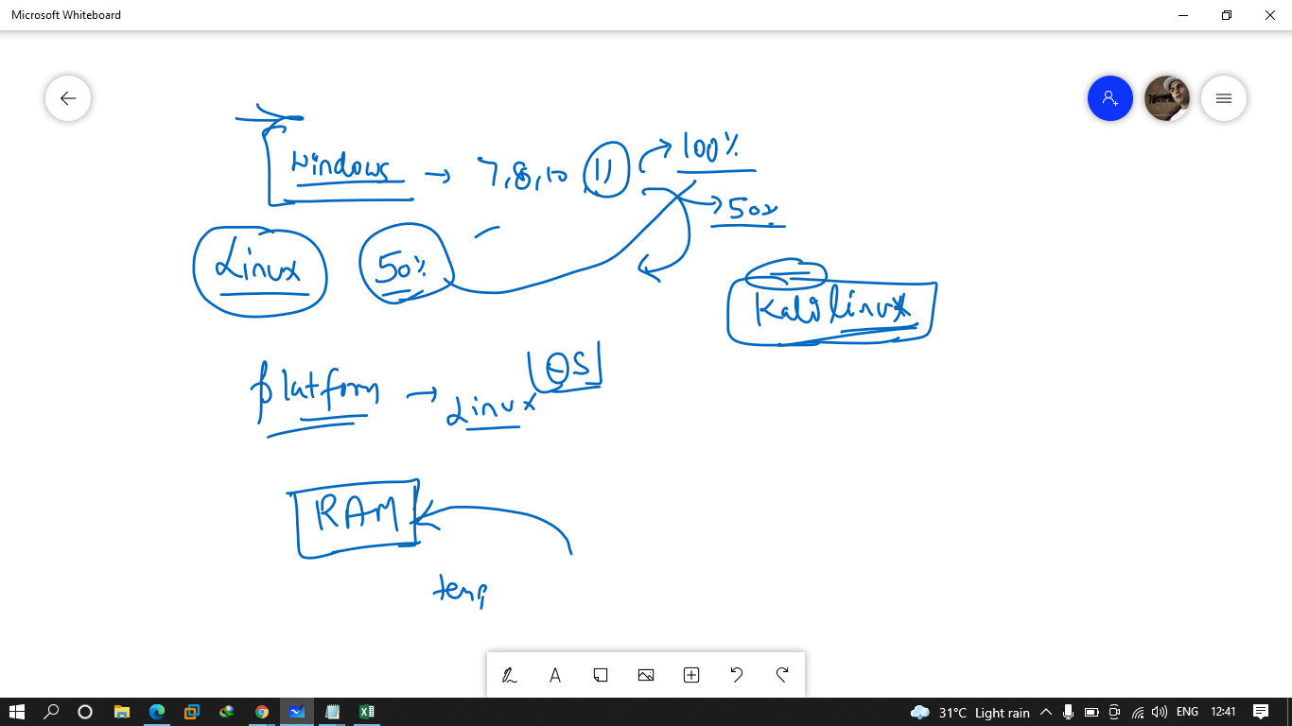

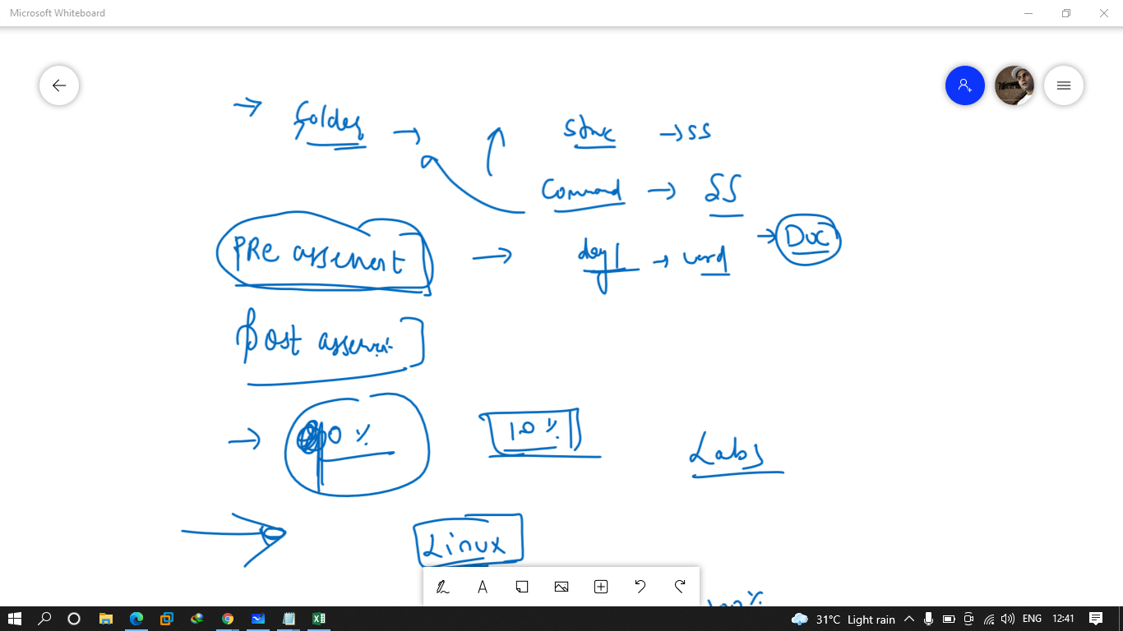

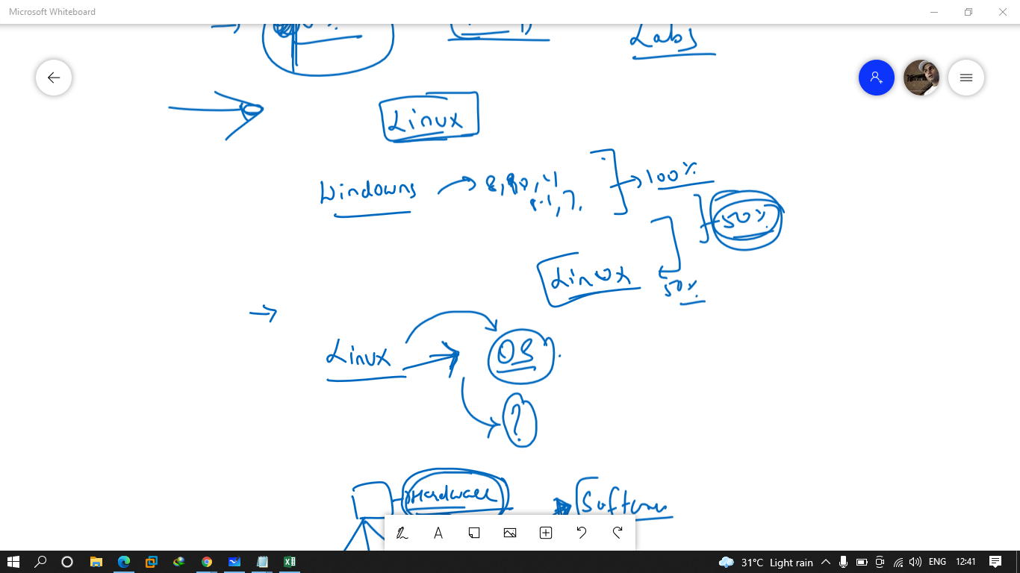

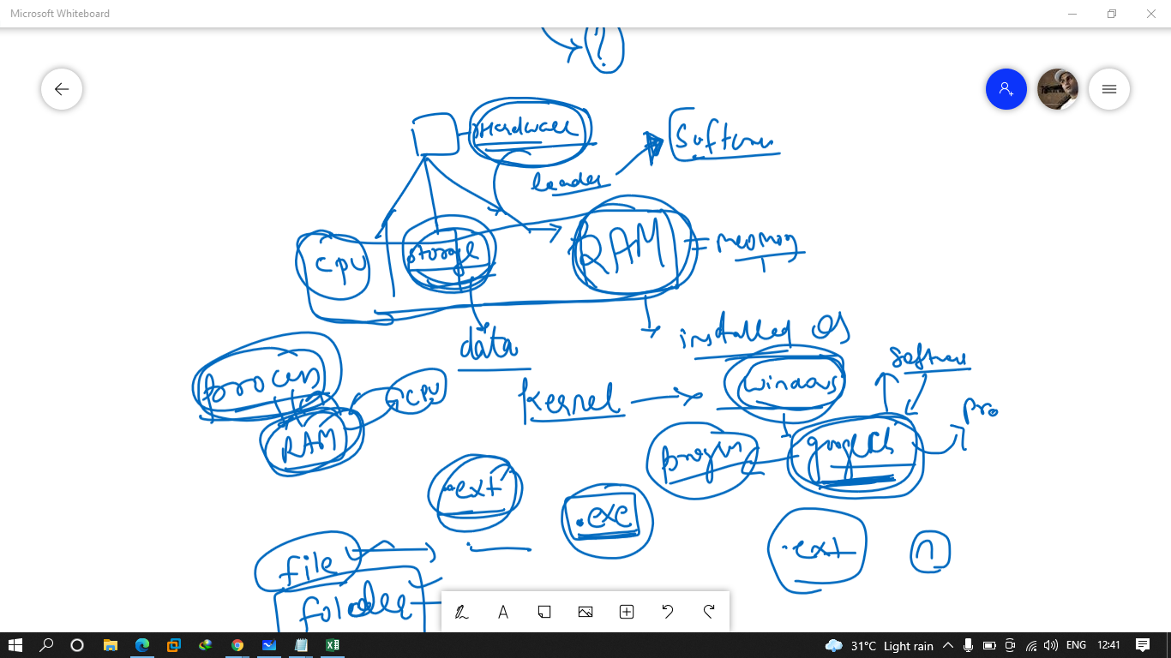

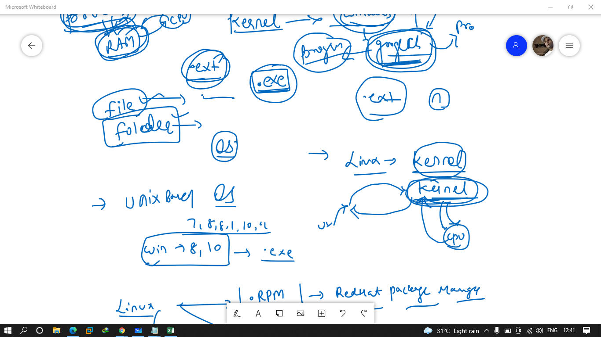

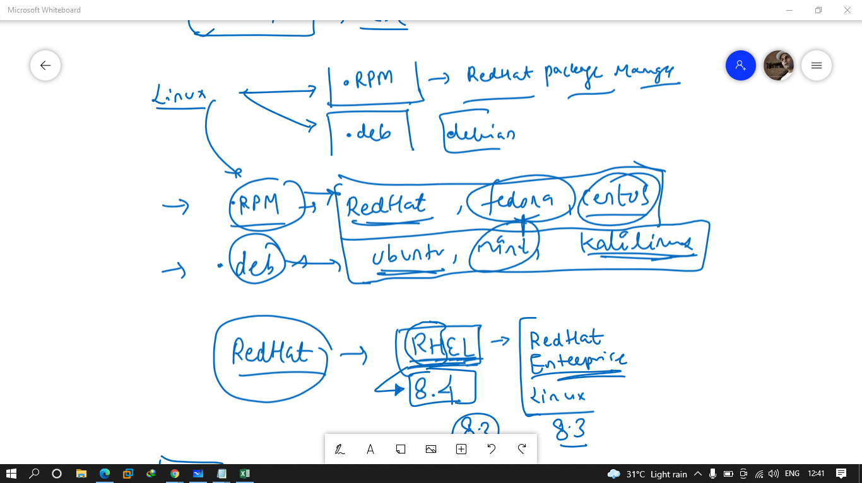

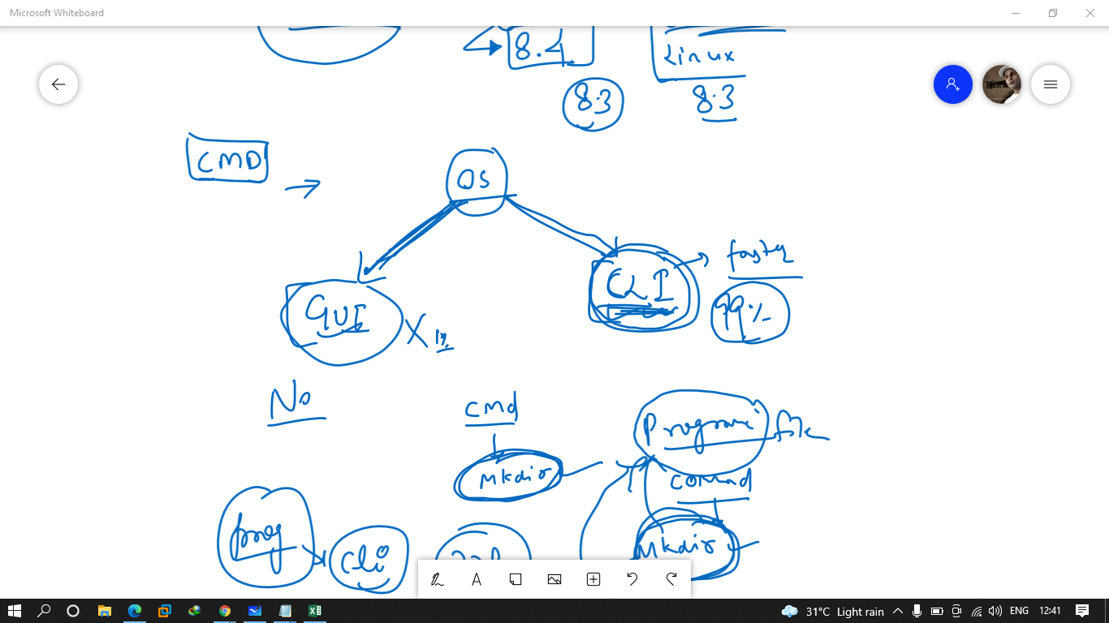

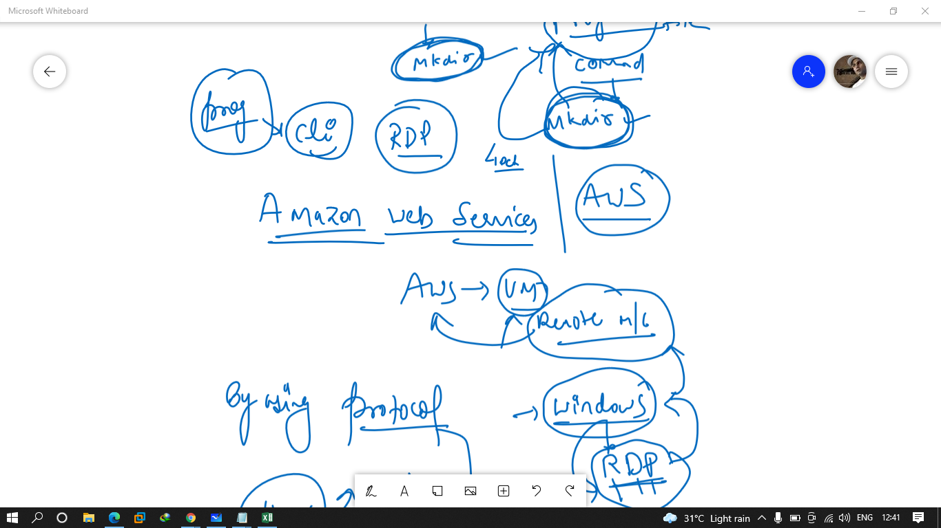

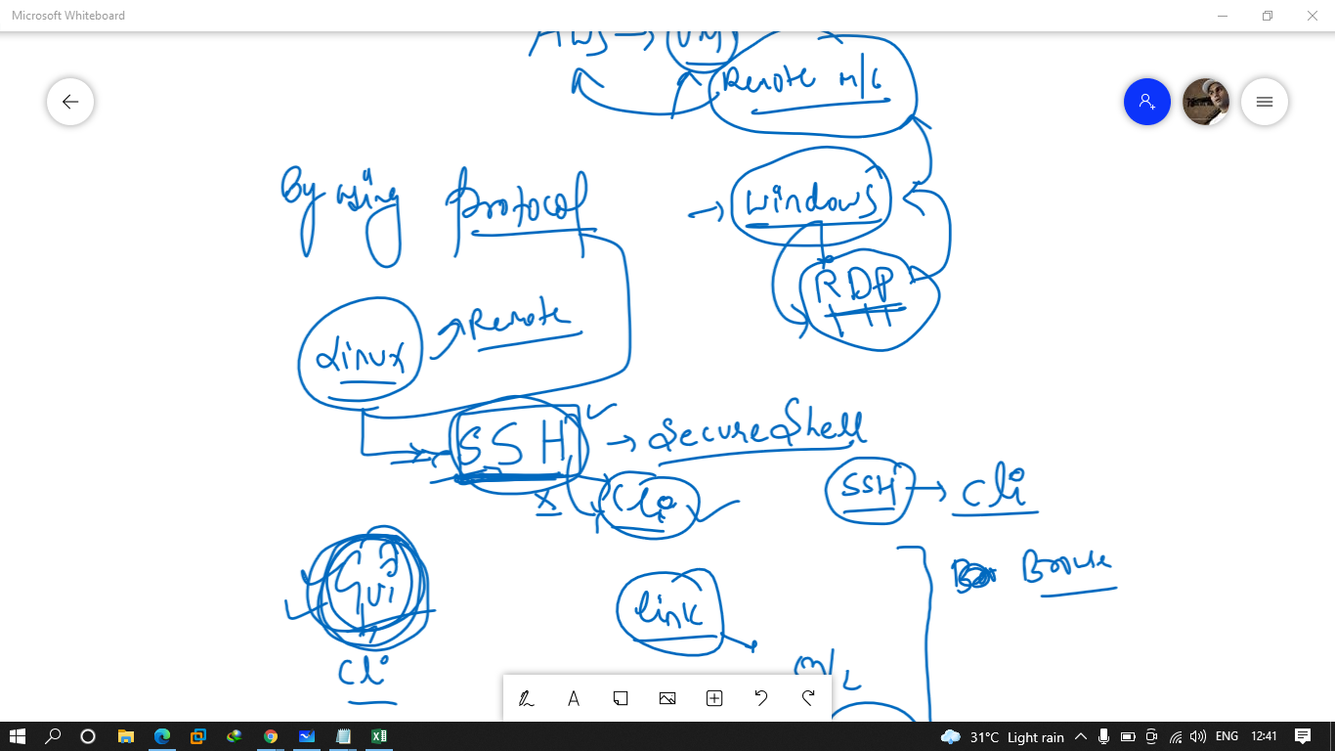

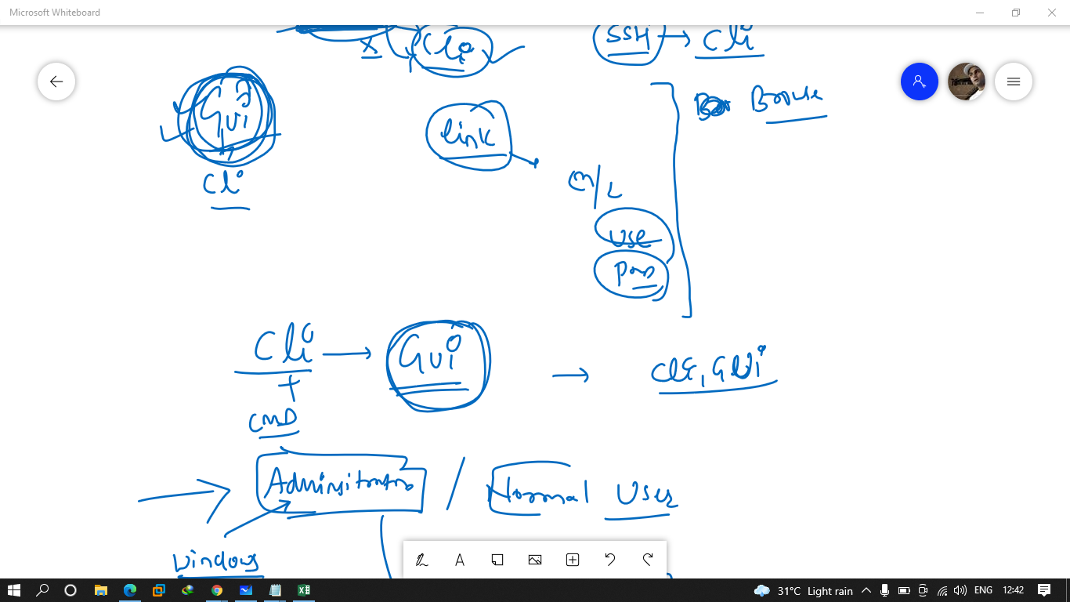

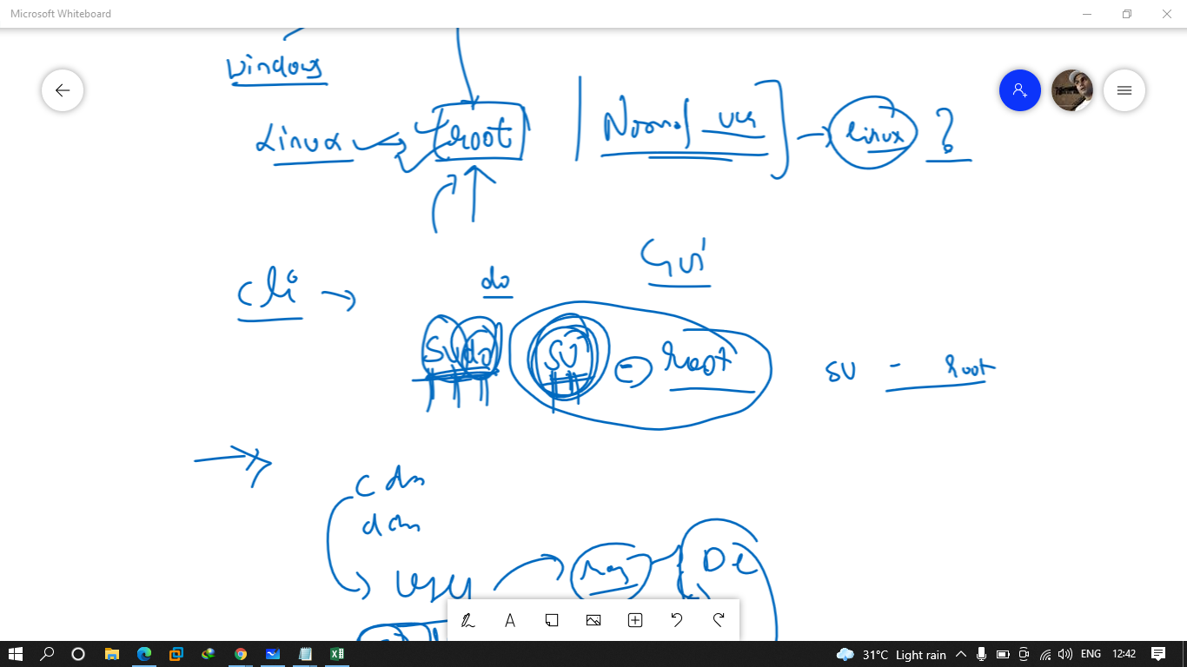

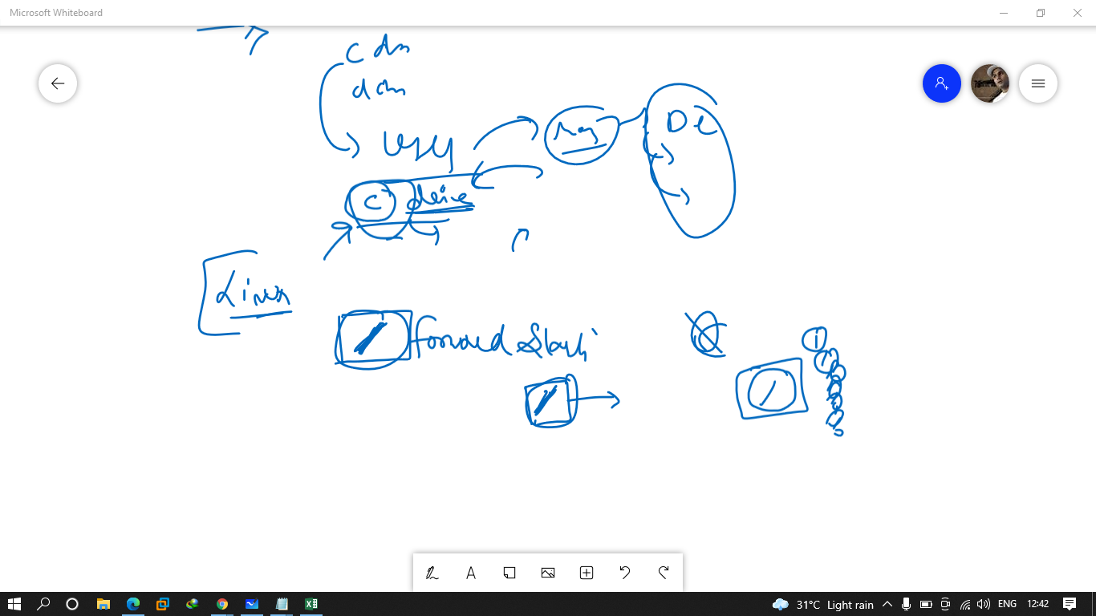



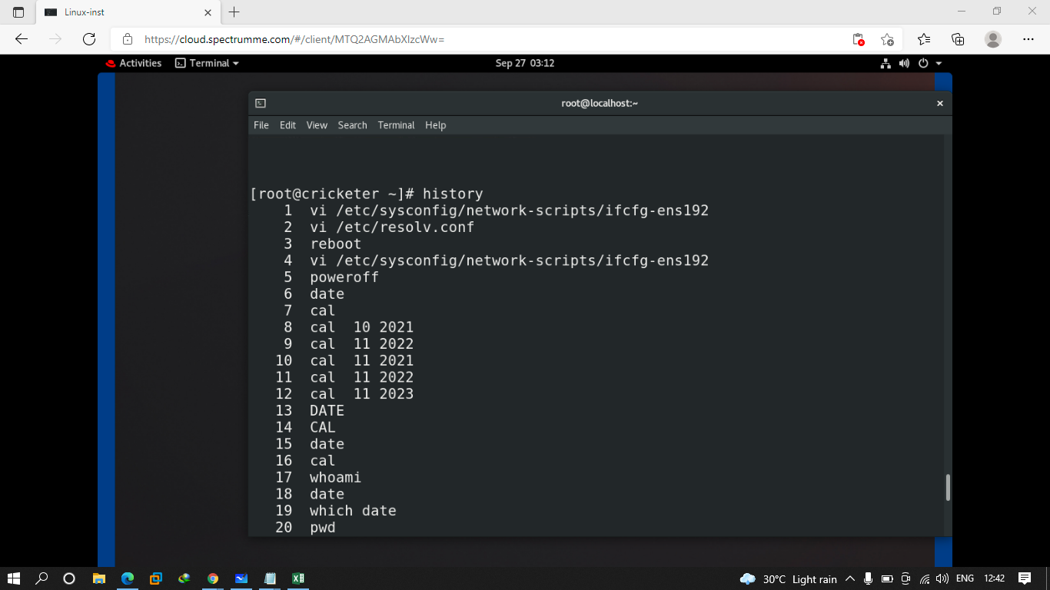

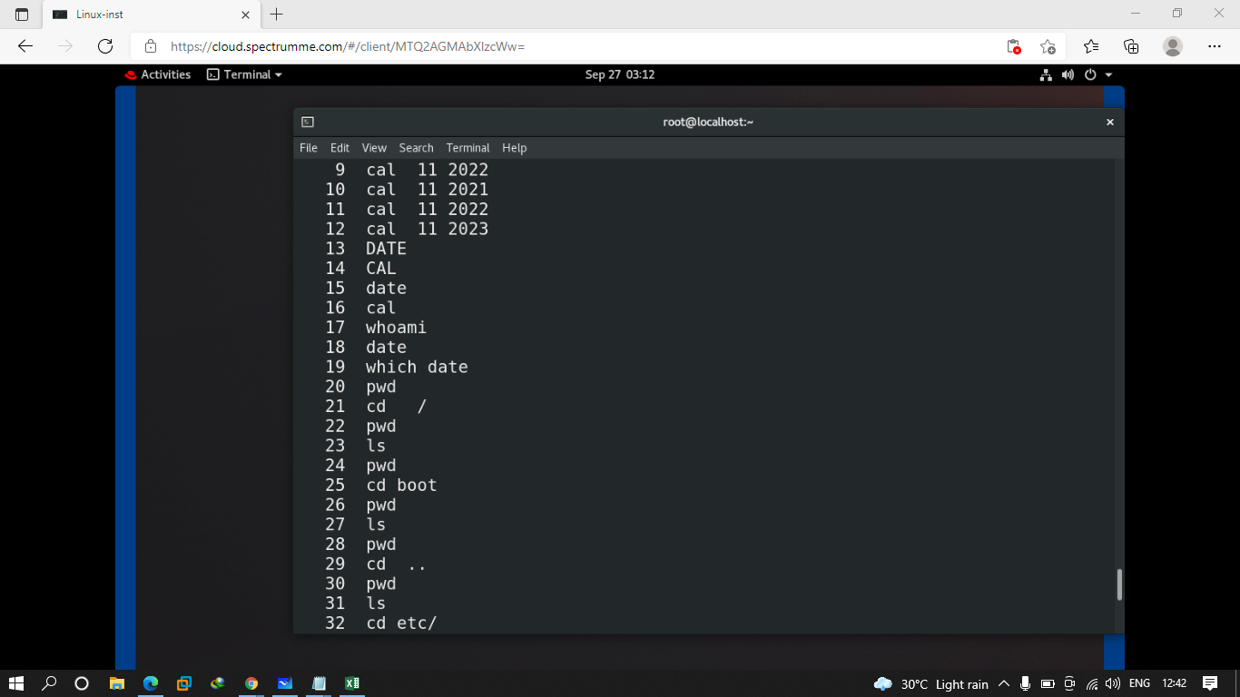

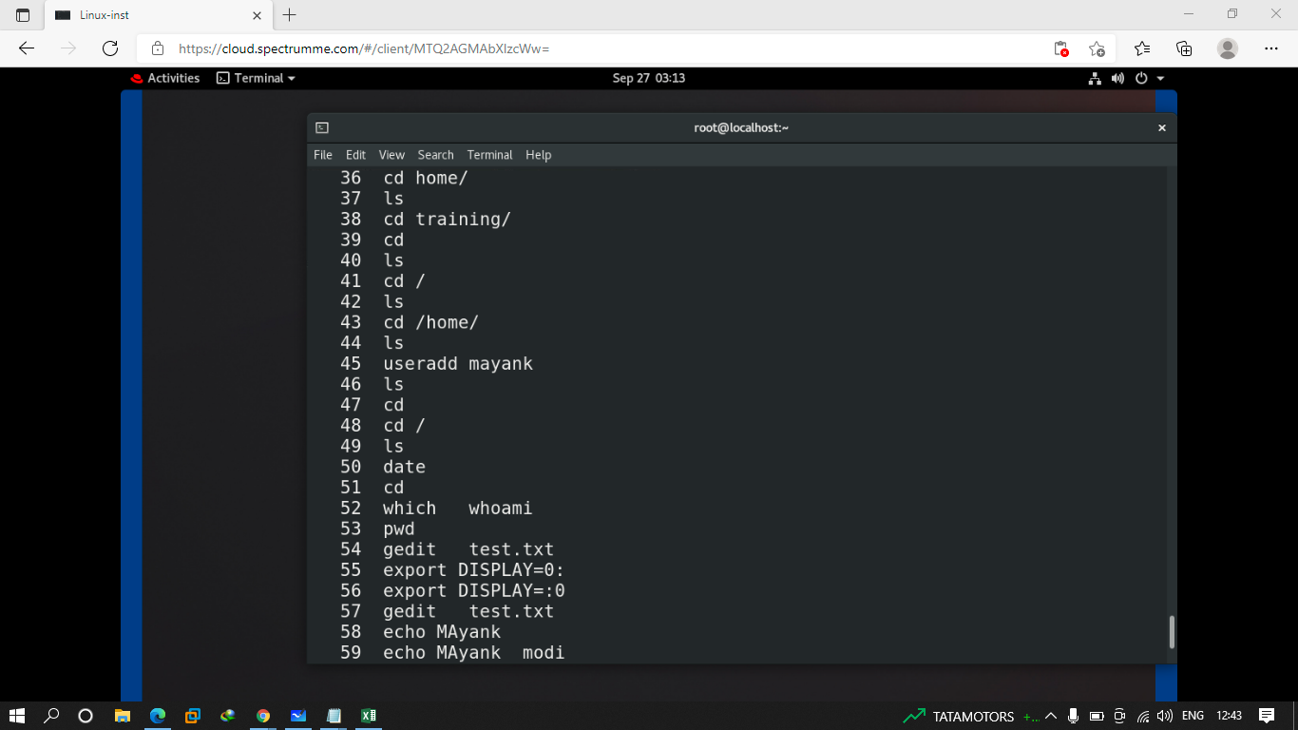

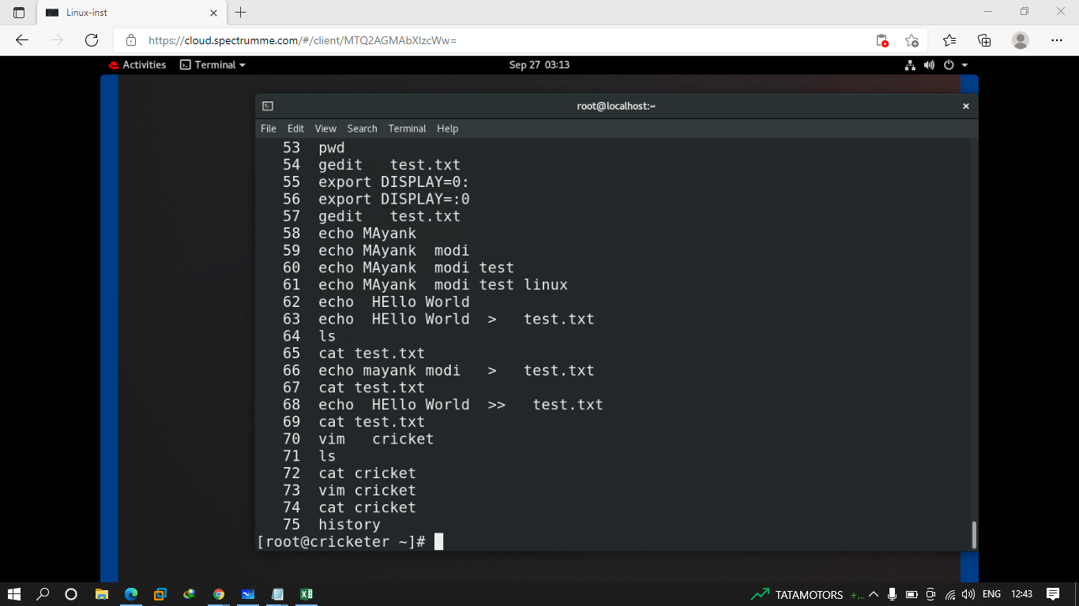

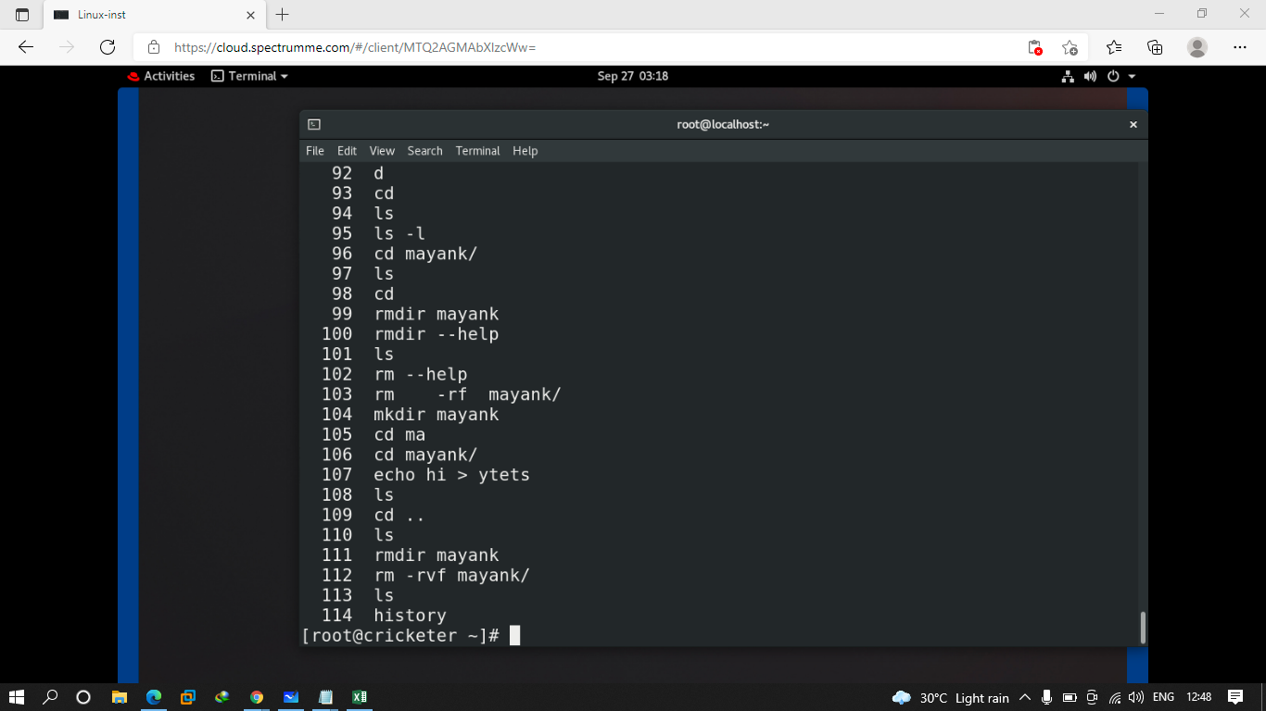

Sudo su - root

root#123

Q.1 create a folder using gui with ur own name

Q.2 create a folder in /root folder with ur own name

Q.3 create file using echo command and after that try to append some text into it

Q.4 create a fileusing vim command and save some content into it

Q.5 create 5 folders with name of file1 to file5 and inside them also create one file each

Q.6 try to verify everyfolder and files in / directory

Q.7 try to remove a file called file1 that u will create in root folder

first --- user./owner -- rw-

247 second -- group permission -- r-- --

248 third other user permission

249 <<X

250

251 user/owner --- group permisson = == other user permission

252 rwx rwx rwx

253 folder --- rwxrwxrwx

254 mkdir er

255 ls -l

256 <<X

257 read and exexcution

258 owner -- rwx

259 <<X

260 DENOted -- rwx -- numerical value

261 rwx -- read -- 4, write - 2 , execute -- 1

262 rwx -- 7

263 complte permission -- rwxrwxrwx -- 777

264 cd

265 useradd mayank

266 su - mayank

267 whoami

268 touch mayank

269 ls -l

270 mkdir code

271 ls

272 cd code/

273 ls

274 rm -rf \*

275 ;sl

276 ls -l

277 pwd

278 touch mayank

279 ls -l

280 chmod o+wx mayank

281 ls -l

su - mayank

283 ls -ld /root/

284 chmod o+rwx /root/

285 ls -ld /root/

286 su - mayank

287 ls

288 ls -l

289 chmod o-rwx mayank

290 su - mayank

291 cd

292 ls

293 cd code/

294 ls

295 ls -l

296 chown mayank mayank

297 ls -l

298 chgrp mayank mayank

299 ls -l

300 <<X

301 ls

302 ls -l

303 <<X

304 rw- r-- r--

305 ls -l

306 chmod 644 mayank

307 ls -l

308 chmod 457 mayank

309 ls -l

310 chmod 123 mayank

311 ls -l

312 rm -rf \*

313 touch testfile

314 ls -l

315 mkdir testfolder

316 ls -l

317 <<X

318 644 -- FILE

319 <<X

320 <<X

321 777

322 service linux --- umask -- default permission in linux

323 umask

324 <<X

325 777 - 022 = 755 == folder

326 rwxr-xr-x == 755 folder permission

327 755 - xxx == 755 -111 == 644 file

328 umask -- 123

329 trell me folder --- 654 --- file

330 654 -- rw-r-xr-- -- 644

331 234 umask -- folder -- 543 -- file -- 442

332 543 -- r-xr---wx

333 258 -- flder -- 519----

334 <<XC

335 rwx ---- threee -- owner / group / other

336 rwx rwx rwx

337 chmod chnage

338 chown chgrp

339 numberical value

340 max 777

341 cd

342 mkdir test

343 umask

344 ls -l

345 umask

346 history

347 su - mayank

348 cd /home/mayank/

349 ls

350 ls -l

351 history

352 useradd ille

353 su - ille

354 su - mayank

355 passwd ille

356 su - mayank

Q.1 create a folder with ur name by root user in location /root/mayank/tets1/test2/name

Q.2 after creating change the permission to 654 but by using alphabet way not the numerical way

Q.3 create a folder using a username test and give that folder permission of 444

Q.4 create a test folder by using test user only in location /home/test/mayank/chck/task2/

Q.5 umask values are given you need to let me know about the folder and file permission

1. 522
2. 433
3. 566
4. 768
5. 222
6. 567
7. 222
8. 622
9. 534
10. 667

Q.6 creat 3 user and give them password as well

67 ls -l

368 touch {1..100}

369 ls

370 ls -l

371 ls

372 cd ..

373 ls

374 tar cvf test.tar /test/\*

375 ls

376 tar --help

377 ls

378 tar tvf test.tar

379 l

380 ls

381 mv test.tar /var/

382 cd /var/

383 ls

384 tar --help

385 ls

386 tar -xvf test.tar

405 tar --help | grep gzip

406 grep --help

407 tar --help | grep -i gzip

408 ls

409 cd ..

410 ls

411 cd /test/

412 ls

413 cd ..

414 ls

415 tar czvf test1.tar.gzip test/\*

416 ls

417 tar xzvf test1.tar.gzip

418 ls

419 cd test/

420 ls

421 rm -rf \*

422 ls

423 cd ..

424 ls

425 tar xzvf test1.tar.gzip

426 cd test/

427 ls

428 cd ..

429 ls

430 las

431 ls

432 tar --help | grep bzip2

433 tar cjvf test2.tar.bz2 test/

434 ls

435 tar xjvf test2.tar.bz2

436 tar --help | grep -i xz

437 tar cJvf test3.tar.xz test/

438 ls

439 tar xJvf test3.tar.xz test/

440 ls

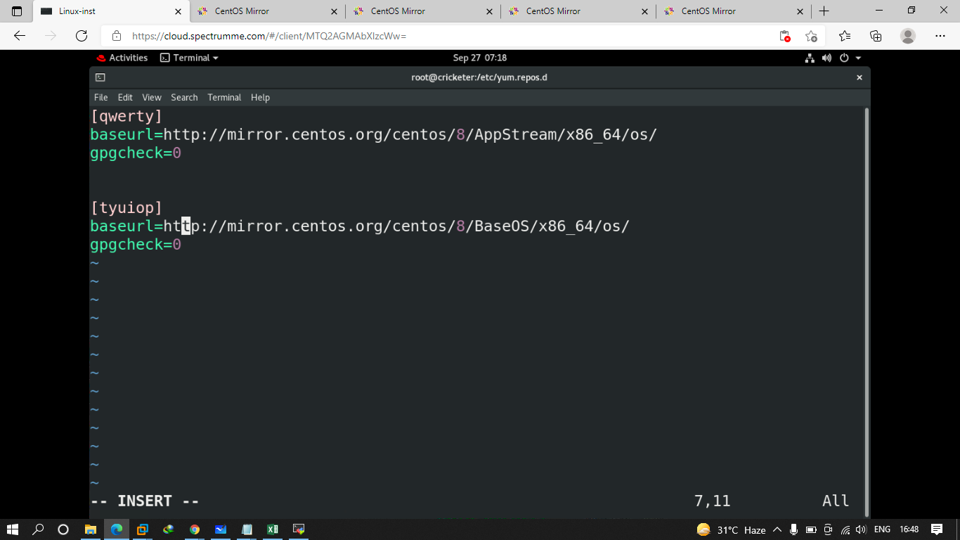

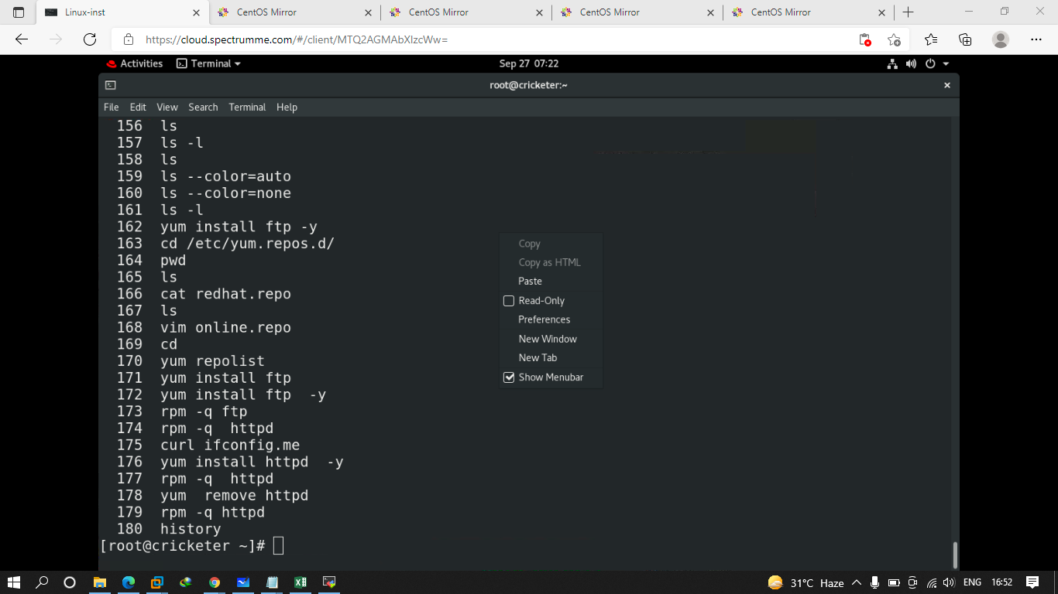

Q.1 create a directory in that create 26 files and files name should be alphabet

Q.2 create a normal tar ARCHIVE file with test1 name

Q.3 create tar file using a complressoon technique called gzip

Q.4 create tar file using compression technique called bzip2

Q.5 create tar file using compression techniqu xcalled xz.

Q.6 configure to install multiple software like ftp vsftpd httpd bash-completion

The urls that u can use is

<http://mirror.centos.org/centos/8/AppStream/x86_64/os/>

<http://mirror.centos.org/centos/8/BaseOS/x86_64/os/>